Los Angeles Trade Tech College

COURSE INFORMATION

MCYCMEK 212

|  |  |  |  |
| --- | --- | --- | --- |
| Instructor | O. Mostafa | Phone | (213)-763-3900 |
| Office | F-124 | E-mail | mostafo@lattc.edu |
| Office hours | M-Th 1:30 to 2:00 pm  Saturdays 2:00 to 2:30 pm | Program | Motorcycle Repair Mechanics |

COURSE DESCRIPTION

|  |  |  |  |
| --- | --- | --- | --- |
| Section | # 10790 - 2/15/25 to 6/07/25 | Semester/Session | Spring 2025 |
| Class Time | 7:30 pm to 2:00 pm  Saturdays | Classroom  Lab. | F- 124  F- 124 |
| Lecture | 3 Hour / Week | Lab. | 3 Hours / Week |
| Title | MCYCMEK 212, MOTORCYCLE TUNE-UP AND CHASSIS MAINTENANCE | Credit | 4 units |

Course offers instruction in the areas motorcycle tune-up, general motorcycle repair and maintenance, including chassis components.

STUDENT LEARNING OUTCOMES

Student will complete manufacturer's check list inspection and adjustment procedures outlined in the maintenance manual. Perform tune-up, valve adjustment and clutch/brake system maintenance

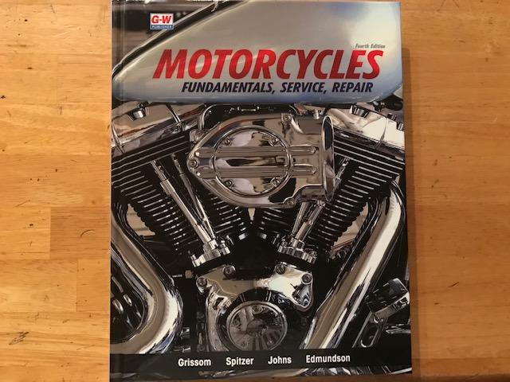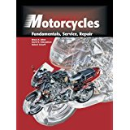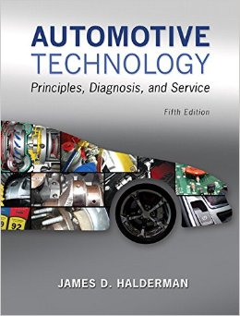  


COURSE REQUIREMENTS

Required book:

MOTORCYCLES: Fundamentals, Service, Repair Old Book

Fourth Edition

ISBN: 978-1-63563-697-0

Authors: Grissom, Spitzer, Johns, Edmundson

Required Clothing

Students are required to purchase department sanctioned work shirts displaying department logo (Student name is optional) from approved venders along with black pants and non-slip footwear. This uniform is a requirement to work in the shop.

Required Tools

General tools plus any additional hand tools required to complete assigned work.

Mandatory safety glasses, latex gloves, etc... (The instructor may list by name additional required items)

GRADES

|  |  |
| --- | --- |
| Point Range | Grade Range |
| **900-1000** | **A** |
| 800 - 899 | B |
| 700 - 799 | C |
| 600 - 699 | D |
| 599 or below | F |
| *Student must earn a “C” or higher in order to receive credit towards a Certificate of Achievement.* | |

|  |
| --- |
| ACTIVITIES |

|  |  |  |  |  |
| --- | --- | --- | --- | --- |
| Day | Date | Subject | Attendance / Points | HW + TEST / Points |
| Sa. | 2/15 | Holiday |  |  |
| Sa. | 2/22 | Orientation & introduction to Tires and Wheels, Chapter 16, P 327 | 25 |  |
| Sa. | 3/1 | HW of Wheels | 25 | 20 |
| Sa. | 3/8 | Clutches, Chapter 19, P 411  Quiz 1 of Tires | 25 | 45 |
| Sa. | 3/15 | HW of Clutches | 25 | 20 |
| Sa. | 3/22 | Tune-up & Maintenance, Chapter 24,  P 533  Quiz 2 of Clutches | 25 | 45 |
| Sa. | 3/29 | HW of Tune-up  Quiz 3 of Tune-up | 25 | 20  45 |
| Sa. | 4/5 | Brakes, Chapter 17, P 351 | 25 |  |
| Sa. | 4/12 | Spring break |  |  |
| Sa. | 4/19 | Brakes | 25 |  |
| Sa. | 4/26 | HW of Brakes | 25 | 20 |
| Sa. | 5/3 | Valve adjustment  Quiz 4 of Brakes | 25 | 45 |
| Sa. | 5/10 | Valve adjustment | 25 |  |
| Sa. | 5/17 | Quiz 5 of Valve adj. | 25 | 45 |
| Sa. | 5/24 | Frames, Chapter 18, P 381 | 25 |  |
| Sa. | 5/31 | HW of Frames  Quiz 6 of Frames | 25 | 20  45 |
|  |  |  |  |  |
| Sa. | 6/7 | Lab test  Written test |  | 100  180 |
|  |  | Sub total | 350 + | 650 |
|  |  | Total | 1000 |  |

**Student Attendance Policy:**

1. An instructor may exclude a student who is absent for more hours than the class meets per week or 20% of the total class hours.
2. In addition, an instructor may equate three or more late arrivals to or early departures from class as an absence for purposes of class attendance.

**General Conduct:**

I care about my students, your success, and in the environment in which we work together: therefore, I reserve the right to remove students from the classroom who disrupt our learning process and/or create a distracting or hostile class environment.

**Cell Phone / electronic Devices:**

*Please turn off all electronic devices before you enter the classroom. Talking or placing calls or text messages during the lecture is unacceptable and will lead to a dismiss from the class.*

**Academic Integrity:**

A violation of Academic Integrity of any type by a student provides grounds for disciplinary action by the instructor or college. Violations of Academic Integrity include but are not limited to: cheating on an exam, plagiarism, working together of an assignment, paper or project when the instructor has specifically stated students should not do so, submitting the same term paper to more than one instructor, or allowing another individual to assume one’s identity for purpose of enhancing one’s grade. If necessary, please refer to the LACCD student code of conduct as it relates to student dishonesty (Board Rule 9803.28)

**Disabilities:**

If you have a documented disability that may interfere with your ability to fully participate in this class, you may be eligible for accommodations. Students with disabilities who need assistance or accommodations, should contact the instructor in a timely manner. The DSPS office is available to assist with accommodating a disabled student at (213) 763-3773 and is located in Mariposa Hall 100.

**Disclaimer:** Some revisions may be necessary during the course. If you do not show up in the exam days, it is an automatic fail.  ***The syllabus and/or schedule are subject to change***.